**Assessment of Water Quality in Duke Gardens South Pond, Duck Pond, and Upper Pond. 2019 Results**

**Purpose**

This report is a summary from an ongoing assessment monitoring water quality and nutrient input into the three Duke Garden ponds. These ponds are of interest because of their flow to the impaired waterways of Sandy Creek and all the way downstream to Jordan Lake.

**Methods**

All three Duke Garden ponds are sampled monthly in this 2019 study (South Pond, Duck Pond, Upper Pond). Three replicate samples were collected from each site at each sampling event. South Pond was not sampled in March 2019 because it was drained by Duke Gardens. Surface water samples were collected and analyzed for total phosphorus (TP), total nitrogen (TN), total dissolved solids (TDS), ammonia (NH3), nitrate (NOx), total suspended solids (TSS), fecal coliform, and orthophosphate (FOP). Physical measurements of temperature, pH, conductivity, salinity, and oxygen concentration and saturation was measured using a YSI instrument.

Data was analyzed using R software, and linear regressions to determine relationships between certain parameters. A data repository and code used to run statistical tests and create graphics on the data can be found here: <https://github.com/kfm20/DataProject.git>. Please refer to the “README.md” document for metadata and explanation on the purpose of the repository.

Three points were randomly selected for each pond near the sampling locations, but the points are not representative of actual sample locations (*Appendix 1,* *Figure 1*). Each point is assigned a sample number of 1, 2, or 3. Each point represents the assigned sample number for each month. Layers were created from Duke Garden data transformed into CSV format. The maps used GCS WGS 1984 projection.

**Results**

***Research Question 1: What are the general trends over the year?***

Summary results from the year 2019 are reported by site within Duke Gardens, specifically Duck Pond (*Table 1*), South Pond (*Table 2*), and Upper Pond (*Table 3*). The site locations can be seen in the map below (*Figure 2*). Annual mean, minimum, and maximum values are shown for the parameters of TP (µg/L), TN (µg/L), TSS (mg/L), Fecal Coliform (CFU/100mL), and pH. Yearly mean, minimum, and maximum are calculated using twelve sampling events, except for South Pond, where eleven sampling events are used.

Total nitrogen is visually displayed over the year in all three ponds at this site: <https://arcg.is/1HfKH>, and graphically in *Figure 3*. Nitrogen travels through these systems moving North to South. This trend can be seen through the year, with the Upper Pond having the highest concentration in the month of July, then Duck Pond in August. However, this trend occurs less for South Pond. This is difficult to see graphically, and precipitation and flow data may be required to determine if this relationship is statistically correct. Total nitrogen did not have the highest maximum nitrogen concentration, but it did have the highest mean due to the potential nutrient runoff from the adjacent parking lot. All three ponds had the highest concentrations of nitrogen in the month of June.

Total phosphorus is visually displayed over the year in all three ponds of Duke Gardens here: <https://arcg.is/1C1Cm1>, and graphically in *Figure 4*. Duck pond had the most sporadic concentrations from month to month. Upper Pond concentrations stayed relatively low and constant. Duck Pond had the highest concentrations and average during the summer months. April to July had high pH (*Figure 5)*. South Pond had the highest pH of the three. South Pond is located in the center of a large manicured grass plot, the use of chemicals for maintenance may have altered the pH.

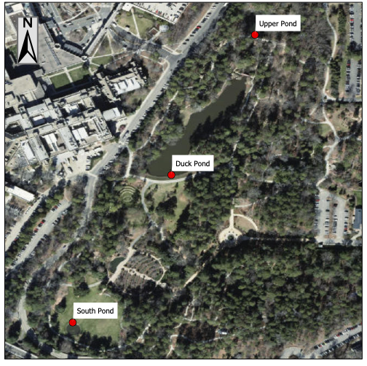

Figure 2. Map of the three sampling sites identified as Upper, Duck, and South Pond, in Duke University’s Duke Gardens.

|  |  |  |  |  |  |
| --- | --- | --- | --- | --- | --- |
| Duck Pond | | | | | |
|  | **TP** | **TN** | **TSS** | **Fecal Coliform** | **pH** |
| Mean | 185.48 | 1411.67 | 27.14 | 150.69 | 6.94 |
| Min | 86.50 | 629.67 | 14.00 | 0.00 | 5.84 |
| Max | 357.67 | 4159.00 | 51.00 | 531.67 | 7.66 |
|  |  |  |  |  |  |

Figure 2. Mean, minimum, and maximum of monthly 2019 Duke Gardens data in Duck Pond.

Table 1. Mean, minimum, and maximum of monthly 2019 Duke Gardens data in Duck Pond.

|  |  |  |  |  |  |
| --- | --- | --- | --- | --- | --- |
| South Pond | | | | | |
|  | **TP** | **TN** | **TSS** | **Fecal Coliform** | **pH** |
| Mean | 150.68 | 1255.39 | 9.73 | 58.48 | 7.31 |
| Min | 88.33 | 612.67 | 0.67 | 0.00 | 6.38 |
| Max | 347.53 | 3328.67 | 20.00 | 193.35 | 7.88 |

Figure 4. Mean, minimum, and maximum of monthly 2019 Duke Gardens data in South Pond.

Table 2. Mean, minimum, and maximum of monthly 2019 Duke Gardens data in South Pond.

|  |  |  |  |  |  |
| --- | --- | --- | --- | --- | --- |
| Upper Pond | | | | | |
|  | **TP** | **TN** | **TSS** | **Fecal Coliform** | **pH** |
| Mean | 101.68 | 1117.28 | 11.44 | 60.56 | 6.81 |
| Min | 50.17 | 622.33 | 4.33 | 0.00 | 5.90 |
| Max | 169.83 | 2024.33 | 19.00 | 146.67 | 7.41 |

Figure 6. Mean, minimum, and maximum of monthly 2019 Duke Gardens data in Upper Pond.

Table 3. Mean, minimum, and maximum of monthly 2019 Duke Gardens data in Upper Pond.

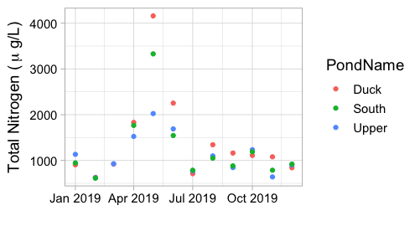

Figure 3. Mean monthly total nitrogen concentrations across all of 2019 in the three Duke Garden Ponds.

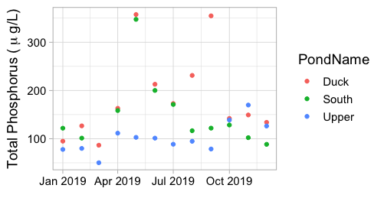

Figure 4. Mean monthly total phosphorus concentrations across all of 2019 in the three Duke Garden Ponds.

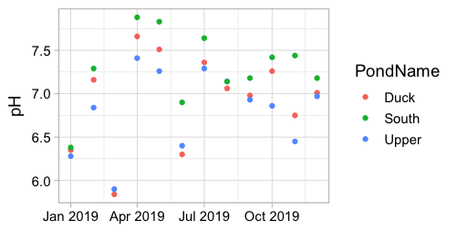

Figure 5. Mean monthly pH across all of 2019 in the three Duke Garden Ponds.

***Research Question 2: Can TSS predict TN or TP concentrations?***

Total suspended solids can not predict total nitrogen for all three ponds in Duke Gardens across 2019 (p-value > 0.0001, R2 = 0.205, linear regression). However, total suspended solids does predict total phosphorus concentrations for all three ponds across 2019, *Figure 5* (p-value < 0.0001, R2 = 0.396, linear regression). TSS and TP have a strong positive correlation (cor = 0.64, Pearson's product-moment correlation).

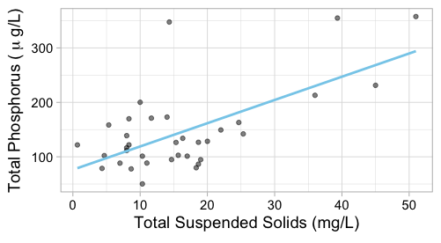

Figure 6. Mean monthly total phosphorus and suspended solids of all three ponds in Duke Gardens over 2019.

***Research Question3: Does fecal coliform predict TN or TP concentrations?***

Fecal coliform cannot be used to predict total nitrogen concentrations, *Appendix 1, Figure 2* (p-value > 0.0001, R2 = -0.03, linear regression). Fecal coliform can also not be used to predict total phosphorus concentrations, *Appendix 1, Figure 3* (p-value > 0.0001, R2 = 0.21, linear regression).

**APPENDIX**

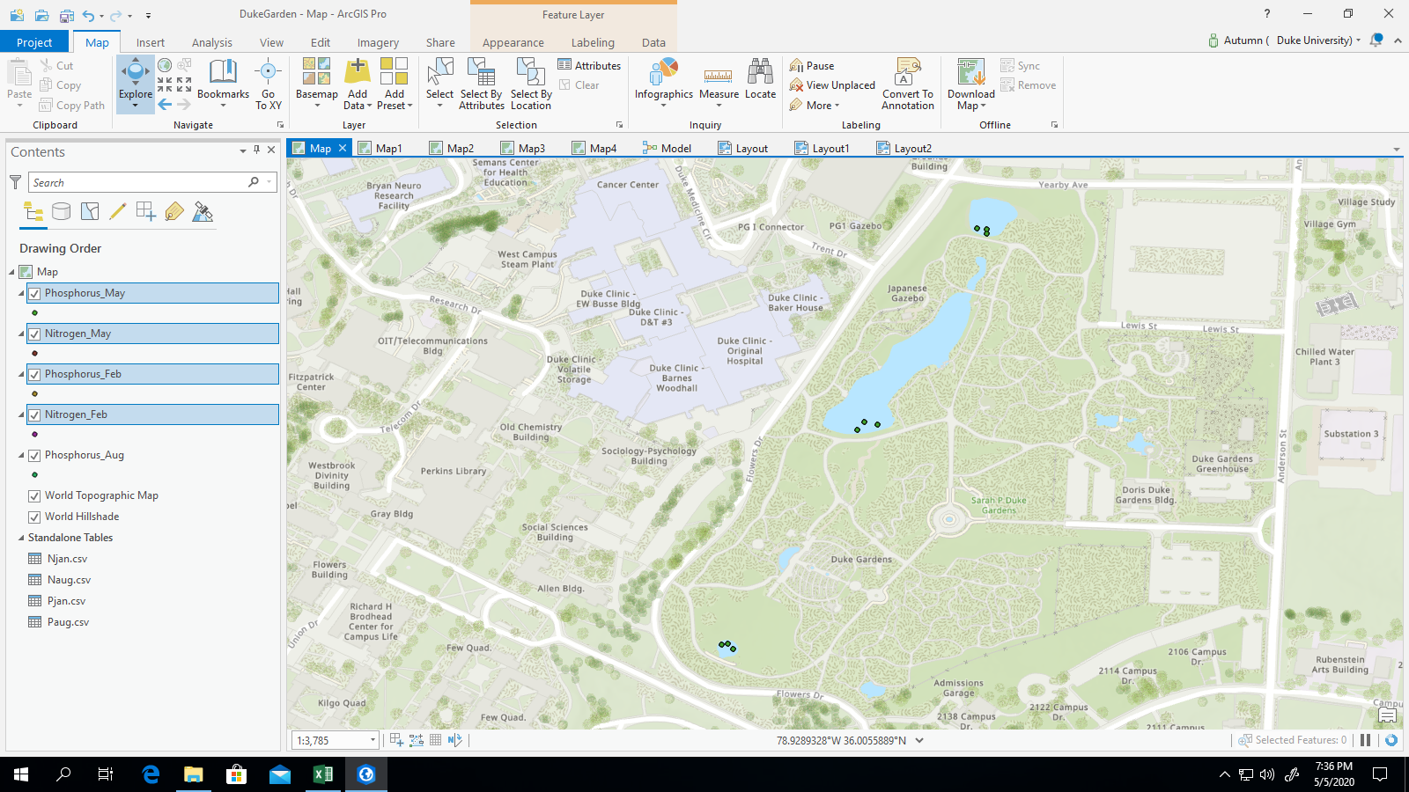

Figure 1. Map of the sample points for Upper, Duck, and South Pond, in Duke University’s Duke Gardens.

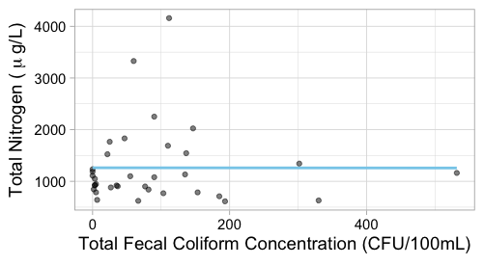

Figure 2. Mean monthly total nitrogen and fecal coliform from all three Duke Garden Ponds across 2019.

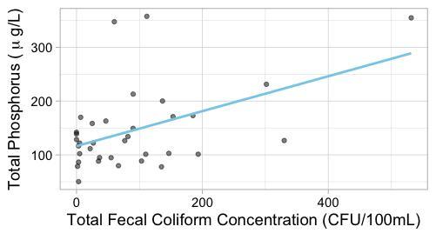

Figure 3. Mean monthly total phosphorus and fecal coliform from all three Duke Garden Ponds across 2019.